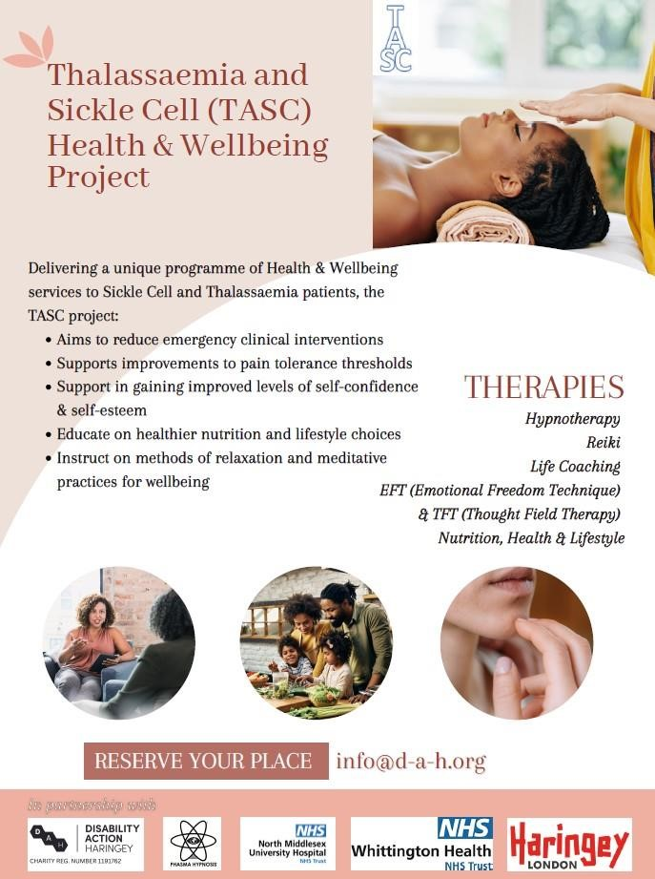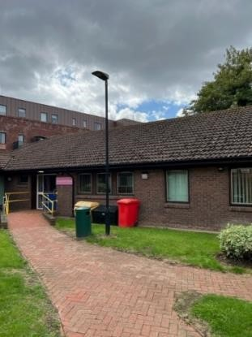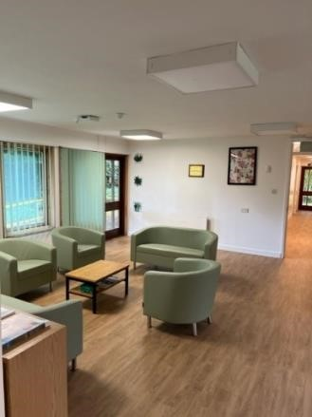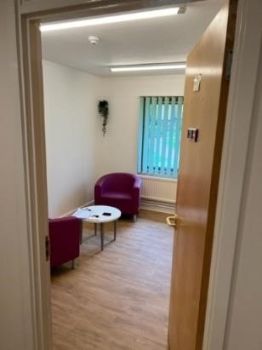

**The George Marsh Centre, St. Ann’s Hospital**

**Project summary:**

The TASC project was developed by Disability Action Haringey and Phasma Hypnosis, codesigned and co-produced with The Sickle Cell Warriors; funded in partnership with NHS Whittington Health & NHS North Middlesex University Hospital and Haringey Council.

The project delivered 120 complimentary therapy sessions for Thalassaemia and Sickle Cell patients across Haringey. The project delivered Phasma Hypnotherapy, Reiki, Life Coaching, Health & Nutrition Coaching, Thought Field Therapies and Emotional Freedom Technique sessions to support with pain reduction/management, anxiety, fatigue and depression; and to increase their quality of life.

Hypnotic & Holistic therapies have a proven track record as methods of drug-free pain control and also of psychological self-healing. Once taught, the participants are equipped with a fast and effective pain management system which can be utilised regularly or as and when needed.

The project also delivered a wellbeing lifestyle coaching service which focused on providing lifestyle and exercise recommendations. This incorporates provision of bespoke menus and supplement plans for each client, to compliment the programme with nutritional knowledge and advice.

Sessions were delivered as complete packages for patients, mixing therapies targeted to identified need, and on an ad hoc basis as and when needed most as a fast intervention for the client. Each service user completed an induction session in which they created a selfmanagement plan with service provider support.

**Project Aims & Outcomes:**

1. The project will aim to deliver several holistic alternatives to medical treatments for sickle cell patients within the borough, with the objectives of:

* Project will reach appropriate number of individuals living with the condition and be representative of the population living with this condition.
* Individual has a self-management plan agreed with professionals.
* Individual achieves longitudinal improvement on self-reported pain threshold, tolerance, and intensity through self-directed interventions, including reduced use of pain medications (if appropriate).
* Individual achieves longitudinal improvement on self-reported confidence and wellbeing through self-directed interventions.
* Reduced non-emergency clinical escalations and emergency episodes

2. The project will aim to deliver several holistic alternatives to medical treatments for sickle cell patients within the borough. This will consist of:

* Reiki sessions to support them with pain management, anxiety, fatigue, depression and increase their quality of life on a 1 to 1 basis, catered for up to 12 to 15 patients.
* Hypnosis and guided mediation sessions within a 1 to 1 and group base settings to several patients throughout the project. Hypnosis therapy has a proven track record as a method of drug free pain control and also of psychological self-healing. Once taught, the participant will be equipped with a fast and effective pain management system which can be utilised regularly or as and when needed.
* The project will also deliver a wellbeing lifestyle coaching service that will focus on providing lifestyle and exercise recommendations. This will be incorporated with the provision of bespoke menus and supplement plans for each patient, to compliment the programme with nutritional knowledge and advice.

**Metrics and Targets:**

* Count of unique users of service
* Count of ethnicity of users of service
* Count of users of service by deprivation quintile (IMD 2019)
* Number of people reporting a: positive impact on overall health and no change or deterioration in overall health
* Number of people reporting a: improved relationships with people important to them no change or deterioration in relationships with people important to them
* Number of people reporting a: increase in their ability to engage in social activities, no change or reduction in their ability to engage in social activities
* Number of individuals who benefited from self-directed interventions, including those from ethnic backgrounds particularly affected by condition.
* Self-reported change in number of health service escalations: non-emergency (eg. GP,

111) and emergency (eg. LAS, A&E and admissions)

* Measure of change in pain and sedative medications used to manage condition. This could be: Number and type of medication, dose (strength or frequency), number of prescriptions over a period of time
* Would Sickle Cell/Thalassemia Warriors recommend the programme to others

**End of Project Quantitative Data:**

**(Metrics & Targets)**

|  |  |
| --- | --- |
| **Unique users of service** | **41 (incl. 6 NTUs)** |
| **Count of ethnicity** | **41 Black British – 100%** |
| **Count of users of service by deprivation quintile (IMD 2019)** | **Q1: 6, Q2-3: 30, Q4: 0, Q5: 5** |
| **Number of people reporting a positive impact on overall health** | **34 (1 non-response) – 99.97%** |
| **Number of people reporting no change or deterioration in overall health** | **0** |
| **Number of people reporting a: improved relationships with people important to them** | **5 (5 stated this as a desired outcome) = 100%** |
| **Number of people reporting no change or**  **deterioration in relationships with people important to them** | **0** |
| **Number of people reporting a: increase in their ability to engage in social activities** | **3 (3 stated this as a desired outcome) = 100%** |
| **Number of people reporting no change or reduction in their ability to engage in social activities** | **0** |
| **Number of individuals who benefited from selfdirected interventions, including those from ethnic backgrounds particularly affected by condition** | **34 = 100%** |
| **Self-reported change in number of health service escalations: non-emergency (eg. GP, 111) and emergency (eg. LAS, A&E and admissions)** | **34 experienced no emergency or non-emergency**  **interventions/admissions during the delivery period. = 99.97%** |
| **Measure of change in pain and sedative medications used to manage condition. This could be: Number and type of medication, dose (strength or**  **frequency), number of prescriptions over a period of time** | **3 users stated a reduction in pain and sedative medication**  **use (frequency). = 100% (of those stating the desired outcome)** |
| **Would Sickle Cell/Thalassemia Warriors recommend the programme to others** | **34 (1 non-response) = 99.97%** |

**(Supplemental Data)**

|  |  |
| --- | --- |
| **Registered non-attending users** | **6** |
| **In person sessions held (George Marsh)** | **24** |
| **Online sessions held (MSTeams, Zoom, WhatsApp)** | **96** |

**Service Delivery (Including multi-disciplinary) over the 120 sessions.**

|  |  |
| --- | --- |
| **Hypnotherapy** | **83** |
| **Reiki** | **11** |
| **NLP EFT/TFT Tapping** | **16** |
| **Life Coaching** | **22** |
| **Health & Nutrition Coaching** | **18** |
| **Talk Therapy (CBT)** | **8** |

**Presenting Symptoms, Conditions & Associated Health Issues**

|  |  |  |
| --- | --- | --- |
| **TYPE** | **No.** | **SESSION TYPE** |
| **Sleep Deprivation** | **16** | **Hypnosis** |
| **Social Anxiety** | **3** | **Hypnosis/CBT/NLP** |
| **Necrosis (Neck/Shoulder)** | **2** | **Hypnosis/Reiki** |
| **Aches (Joints/Back/Hands & Feet)** | **29** | **Hypnosis/Reiki** |
| **Migraine & Headaches** | **20** | **Hypnosis/Acupressure** |
| **Hip Displacement** | **2** | **Hypnosis** |
| **Low Self Confidence/Self Esteem** | **26** | **Hypnosis/CBT/NLP** |
| **Weight Management (under/overweight)** | **9** | **Hypnosis/Nutrition Coaching** |
| **Unhealthy Eating** | **6** | **Nutrition Coaching** |
| **Poor Eyesight** | **2** | **Hypnosis** |
| **Aneurisms** | **2** | **Hypnosis** |
| **Lethargy** | **28** | **Hypnosis/Life Coaching** |
| **Hearing Issues** | **1** | **Hypnosis** |
| **Dependency/Addiction (painkillers)** | **9** | **Hypnosis/Life Coaching/NLP** |
| **Smoking/Vaping Habits** | **6** | **Hypnosis/NLP** |
| **Mobility Issues** | **7** | **Hypnosis/Nutrition/NLP** |
| **Throat Issues (swallowing/drinking/pain)** | **1** | **Hypnosis** |
| **Osteoporosis** | **1** | **Hypnosis** |
| **Cold Extremities** | **23** | **Hypnosis/Health & Nutrition** |
| **Vestibular Migraines** | **3** | **Hypnosis** |
| **Vitriol Eye Haemorrhage** | **2** | **Hypnosis** |
| **Secondary Glaucoma** | **2** | **Hypnosis** |
| **Arthritis** | **4** | **Hypnosis/Health & Nutrition** |
| **Breathlessness/Asthma/Tight Chest** | **18** | **Hypnosis/Health & Nutrition** |
| **Carpal Tunnel** | **1** | **Hypnosis** |
| **Depression** | **12** | **Hypnosis/CBT/NLP** |
| **Lack of Motivation/Focus/Brain Fog** | **22** | **Hypnosis/CBT/NLP/Life Coaching** |
| **Anger** | **3** | **Hypnosis/CBT/NLP/Life Coaching** |
| **Disjointed Memory & Self Perception** | **1** | **Hypnosis/CBT** |
| **Multiple Sclerosis** | **2** | **Hypnosis/Health & Nutrition** |
| **Agoraphobia/Claustrophobia (transport)** | **2** | **Hypnosis/NLP** |
| **Self Harm** | **1** | **Hypnosis/CBT/NLP** |
| **Low Spiritual Esteem** | **3** | **Life/Spiritual Coaching** |
| **Sexual Abuse/PTSD** | **1** | **Hypnosis/CBT/NLP** |

**Subjective Units of Distress (SUDS)**

**Pain Threshold, Tolerance &**

**Intensity:**

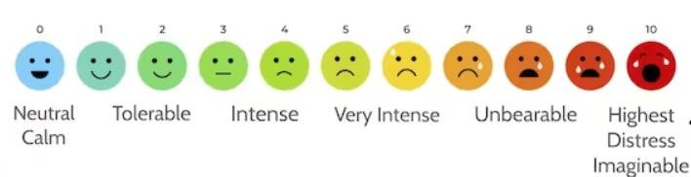

# Preliminary Attending range: 6 – 10 (Average from 30 SC/HBSS patients)

**Project mid-term range: 4 - 5**

**Project end range: 2 – 3**

**Confidence, Self**

**-**

**Confidence & Wellbeing**

**:**

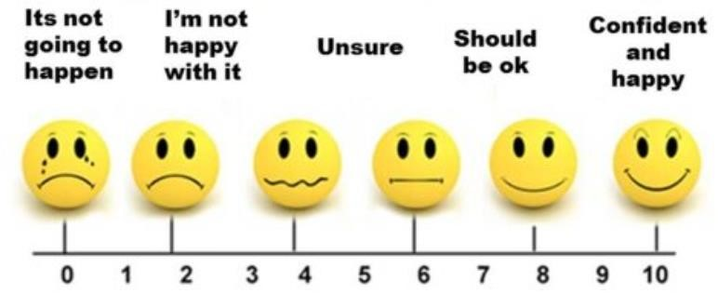

# Preliminary Attending range: 1 - 4 (Average from 30 SC/HBSS patients)

**Project mid-term range: 7 - 8**

**Project end range: 8 - 10**

**Qualitative Data Review:**

**Testimonials**

**On pain management:**

*“I feel good. Relaxed. Much better. The pain has gone down from a nine to around a five. My shoulder feels much, much better. Right at this minute, I can barely feel it.”*

*“I can feel the pain dissipating, it might have been a blockage, but I can feel looseness now.”* **On self-confidence & self-esteem:**

*“Before this I was a 5, now I am an 8 and I’m optimistic and hopeful.”* **On anxiety:**

*“I used to get a sense of dread, now I’m enjoying the space a lot more. Now I feel quite calm and happy, and I really like the space.”* **On productivity:**

*“Now I can prepare myself mentally and just get on with it, things have calmed down and I can just get on with things without anxiety.”* **On Life:**

*“I think the sessions are working very well to be honest. The exercise with the areas of life, I can actually see where areas have improved. The exercise just seems to always be there, it’s always available. The exercises really do help, and I’ve seen improvement in myself.”*

*“Social interactions have definitely improved. I am more focussed on what the purpose is I’m planning to achieve, rather than the situation itself and who’s there and not there. Now I can comfortably be in that space.”*

*“I feel like I’m winning.”*

**Old (Sickle Cell) mantra**

*“When it rains, I’m in pain.”*  **New mantra**

*“When it rains, I manage my pain.”*

Participants have cited the TASC project as significantly reducing dependency on over-thecounter painkillers, improved sleep patterns, increased self-confidence, greater self-esteem and new & improved methods for self-managed pain reduction through relaxation, meditation and visualisation techniques.

**General Comments & Conclusions:**

All participants expressed a wish to continue with the project should it be made available again in the future.

Although hypnotherapy was the predominant form of therapy utilised by the user group, there was a desire to try alternative therapies in conjunction with existing forms, if more sessions were to be made available.

99.97% of users expressed improved quality of life following attendance on the project. (1 user disengaged from the project and could not be consulted).

All service users with Sickle Cell Trait (6 service users) presented with symptoms associated with SC and HBSS, including sleeplessness, muscle, joint and back ache, coldness/numbness in extremities and headaches/migraines. They also expressed that symptoms were exacerbated by bad weather, as is the case in SC and HBSS. Predominant issue for the SC Trait group were confidence/self-confidence and life skills/coping strategies.

The success of the project for Sickle Cell patients can translate across to other long-term health conditions whose symptoms can be correlated to those presented during the project timeframe.

Supplemental therapies utilised during project delivery included Neuro-linguistic Programming, Cognitive Behavioural Therapy, Parts Therapy, Free Association, Acupressure, Regression and Person-centred Therapy.